Discription

This description is about my project Telephone directory (Phonebook).

The feature of telephone directory system are mainly related to creating ,

Searching , modifying , deleting records . All these operation are done through file handling . all the created and modified record are in file , and deleted record

Removed from file.

The information contained in the telephone directory records are the name(only first word) , number , Email ID , Work .

1. Create record :-
2. Search record :-
3. Modify record :-
4. Delete record :-
5. Exit :-

Header Files Used:-

In this project we required to below header files..

#include<iostream>

#include<fstream>

#include<cctype>

#include<iomanip>

#include<string.h>

This page shows the topic of mini-project and which is made by me.

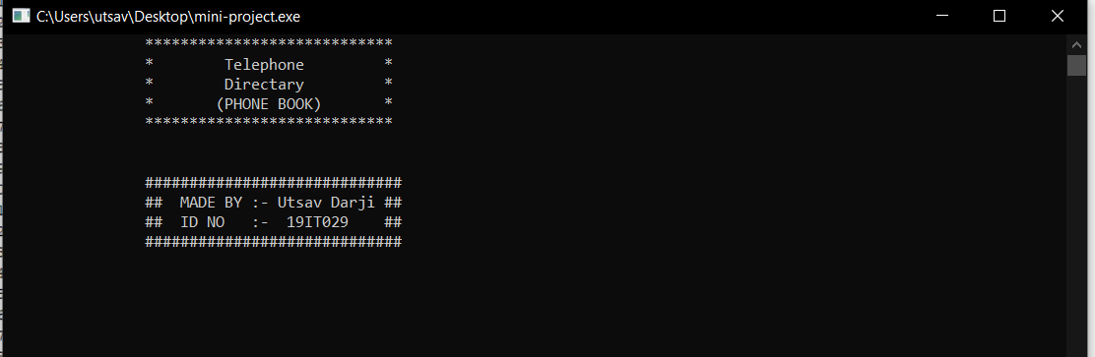

There is Main Menu which shows some option you choose one number.

You should choose only(1-5) number . if you enter any other number output should be nothing to display on screen.

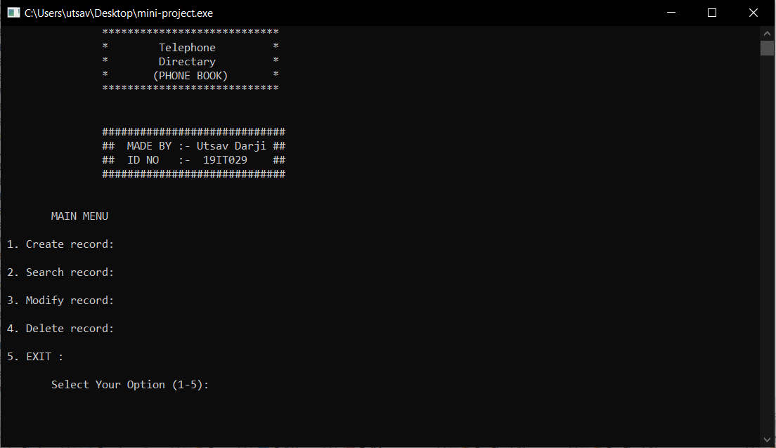

These page shows that there is number 1 is choose by user .

This number is for create a record,There is four information taken by user which is name , number , email id , work.

Here ,I request you to take a one character only for name.

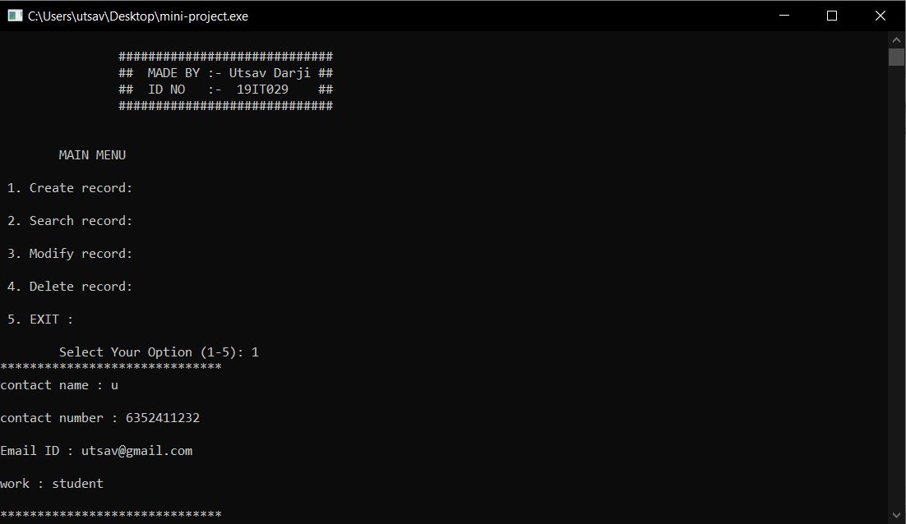

These page shows that user choose 2 number.

These number is for to search a contact by their name.

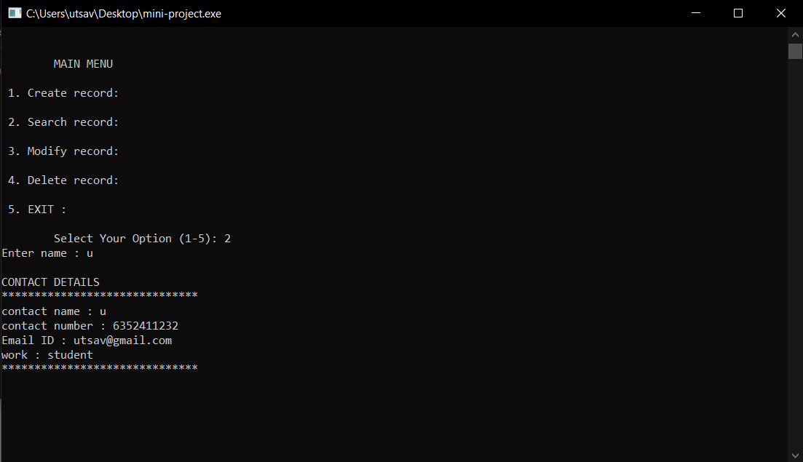

These page shows that user choose 3 number.

These number is for to modify a contact information.

Here we can change all the information of contact.

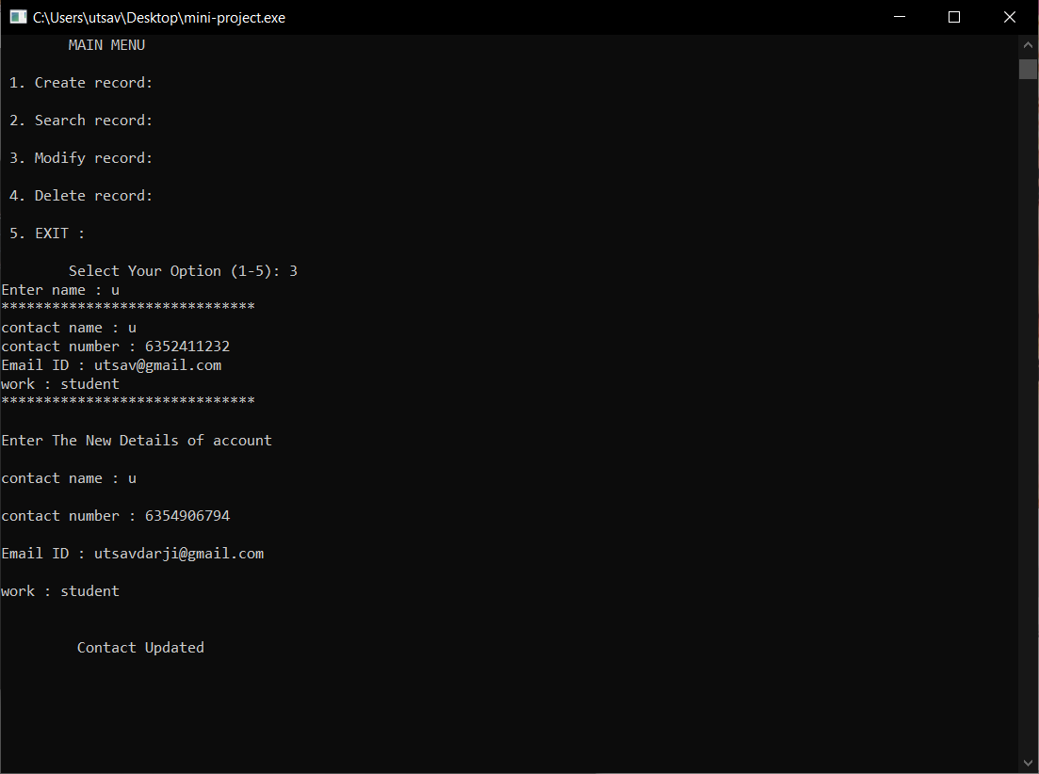

These page shows that user choose 4 number.

These number is for delete a contact .

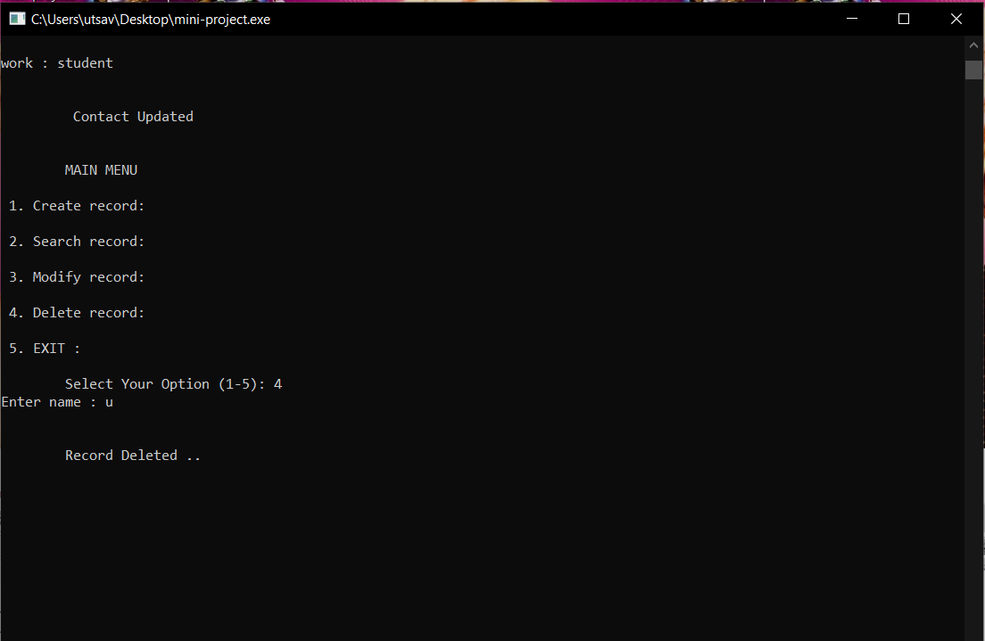

At the last user choose the number 5 .this number is for exit from the programe. 